­­

Utah Lake Water Quality Study

Mass Balance Methodology

April 10, 2020

Contents

1 Executive Summary 4

2 Utah Lake Mass Balance Methodology 5

2.1 Introduction 5

2.2 Watershed Characterization 5

2.3 Utah Lake Watershed LandUses 7

2.4 Tier 1 Mass Balance Approach 9

2.4.1 Tier 1 Objectives 10

2.4.2 Point & Nonpoint Source Data 10

2.4.3 Water Budget 11

2.4.4 Determining Streamflow 11

2.4.5 Computing Unmonitored Watershed Contributions 11

2.4.6 Thiessen Polygon Interpolation 12

2.4.7 Annual Water Yield to Annual Load & Watershed Area 13

2.4.8 DWQ Mass Balance Approach Tier 1: Monitored Watersheds 13

2.4.9 DWQ Mass Balance Approach Tier 1: Unmonitored Watersheds 13

2.4.10 Comparison with DWQ, 2007 Mass Balance 14

2.5 Tier 2 Mass Balance 16

2.5.1 Tier 2 Hydrological Influences on Loading 16

2.5.2 Tier 2 Objectives 16

2.5.3 Pressure Transducer Monitoring and Nutrient Loading Sources 17

2.5.4 Flow and Load Duration Curves 17

2.5.5 Computing Attenuation using a Conservative Tracer Part 1 18

2.5.6 Computing Attenuation using a Conservative Tracer Part 2 18

2.5.7 Computing Attenuation using a Conservative Tracer Part 3 18

2.5.8 DWQ Mass Balance Approach Tier 2 19

2.5.9 Comparison to Tier 1 Mass Balance Results 20

2.6 Tier 3 Mass Balance 20

2.6.1 Hydrological Modeling and Considerations 20

2.6.2 Tier 3 Objectives 21

2.6.3 USGS Load Estimator (LOADEST) 21

2.6.4 USGS Weighted Regression on Time, Discharge, and Season (WRTDS) 21

2.6.5 USGS WRTDS Kalman 22

2.6.6 DWQ Mass Balance Approach Tier 3: LOADEST 22

2.6.7 DWQ Mass Balance Approach Tier 3: WRTDS 23

2.6.8 Comparison to Tier 1 & Tier 2 Mass Balance Results 25

Figures

Figure 1. Utah Lake Watershed Boundary Showcasing Subwatersheds and Monitoring Locations. 13

Figure 2. Land Use Distribution in the Utah Lake Watershed. 14

**Tables**

Table 1 Utah Lake Monitored Watersheds. 9

Table 2 Land Uses within the Utah Lake Watershed. 10

# Executive Summary

# Utah Lake Mass Balance Methodology

## Introduction

The Utah Lake Science Panel is developing a nutrient mass balance for Utah Lake. Previous work by DWQ provided mass balance estimates in 2007, and laid a strong foundation for understanding nutrient loading into Utah Lake (DWQ, 2007). The goal of this study is to update the Utah Lake nutrient mass balance with contemporary data for stream and wastewater treatment plant discharges, improve estimates for agricultural, stormwater, groundwater, and natural spring discharges, and include inputs from unmonitored areas of the lake catchment. The approach is being separated into three tiers in order to reproduce and compare previous studies’ results with DWQ’s (Tier 1), to increase the temporal resolution of load estimates (Tier 2), and to input known estimates into hydrological models for the purpose of modeling estimative outcomes (Tier 3).

## Watershed Characterization

In order to create a reliable and replicable mass balance for the lake, an analysis of watershed characterization was conducted. The Utah Lake watershed is approximately 6,442 and consists of 69 delineated, internal watersheds. 5,974 (92.7%) of the total watershed area is monitored through 19 sample sites located in proximity to the lake shore. All major tributaries and 16% of direct drainages are monitored. The remaining 470 (7.3%) of the total watershed area is unmonitored, and consists solely of direct drainages Table 1 and Figure 1.

Table 1 Utah Lake Monitored Watersheds.

|  |  |  |
| --- | --- | --- |
| 69 Total Watersheds | Percentage of Total Watershed Area  ( ) | Relative Percentage of Monitored Area  ( |
| Major Tributaries | 5,885 (91.4%) | 5,885 (100%) |
| Direct Drainages | 557 (8.6%) | 89 (16%) |
| Major Tribs + Direct Drainages | 6,442 (100%) | 5,974 (92.7%) |
| Known Inflows | 6,337 (98.4%) | -- |
| Total Watershed Area | 6,442 | |

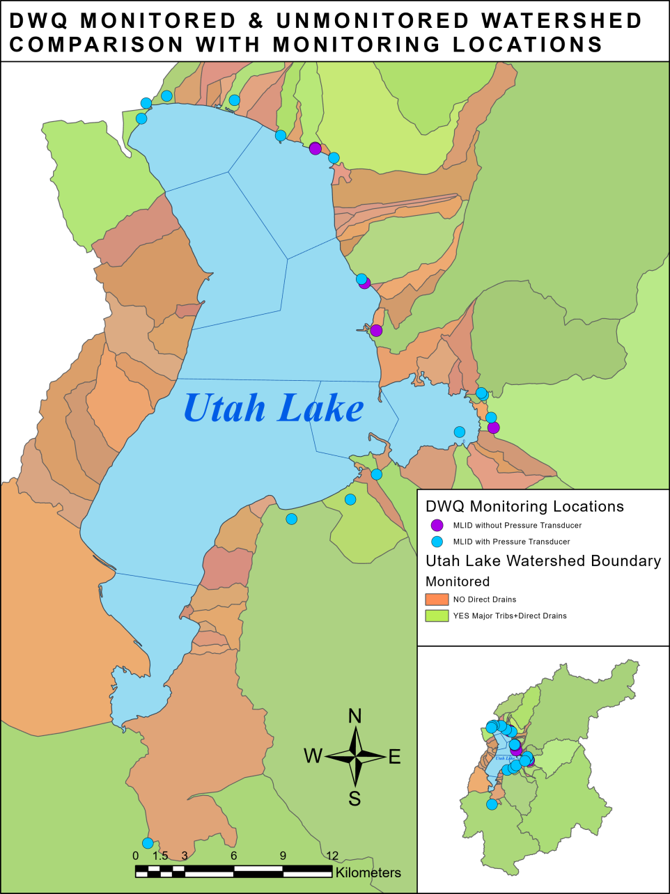

Figure 1 Utah Lake Watershed Boundary Showcasing Subwatersheds and Monitoring Locations.

## Utah Lake Watershed LandUses

Land use characteristics for the Utah Lake watershed from the Multi-Resolution Land Characterization dataset (MRLC) were used to identify urban and residential landscapes contributing to stormwater runoff. Table 2 and Figure 2 show the distribution for all land use types within the watershed. Land uses assumed to contribute stormwater runoff include developed high, medium, and low density residential, industrial, transportation, and built-up open space, which make up approximately 7% of the total watershed area.

Table 2 Land Uses within the Utah Lake Watershed.

|  |  |  |
| --- | --- | --- |
| **Land Use Type** | **Area (acres)** | **Percent Total Area** |
| 31: Barren Land (Rock/Sand/Clay) | 11,302 | 0.81% |
| 82: Cultivated Crops | 49,716 | 3.56% |
| 24: Developed High Intensity | 9,079 | 0.65% |
| 22: Developed, Low Intensity | 33,981 | 2.44% |
| 23: Developed, Medium Intensity | 27,723 | 1.99% |
| 21: Developed, Open Space | 29,138 | 2.09% |
| 95: Emergent Herbaceous Wetlands | 12,699 | 0.91% |
| 42: Evergreen Forest | 234,412 | 16.81% |
| 43: Deciduous Forest | 419,488 | 30.08% |
| 71:Grassland/Herbaceous | 49,427 | 3.54% |
| 43: Mixed Forest | 3,490 | 0.25% |
| 11: Open Water | 94,031 | 6.74% |
| 81: Pasture/Hay | 90,933 | 6.52% |
| 52: Shrub/Scrub | 324,601 | 23.27% |
| 90: Woody Wetlands | 4,741 | 0.34% |
| **Grand Total** | 1,394,761 | **100.00%** |

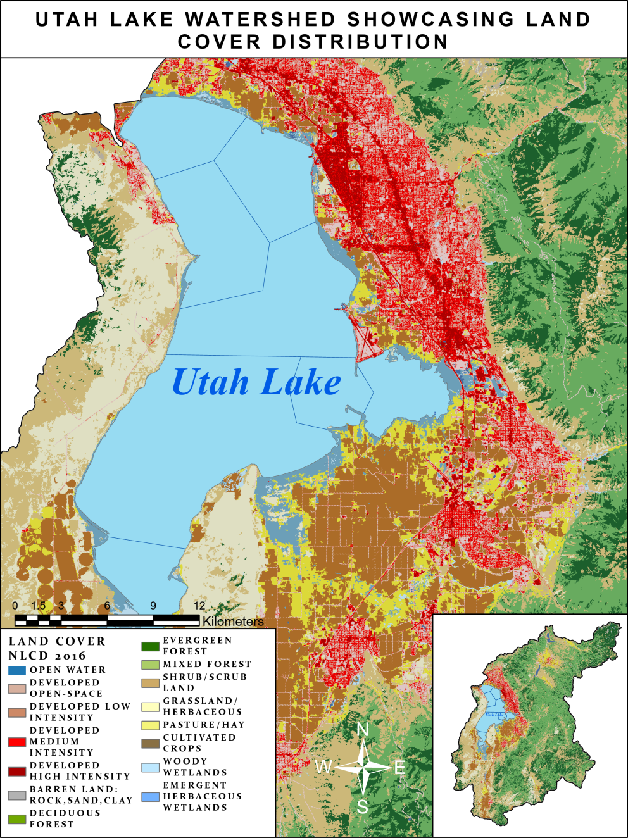

Figure 2 Land Use Distributions in the Utah Lake Watershed.

## Tier 1 Mass Balance Approach

The basic mass balance equation is: [*TP lake = TP input/(1+θσ)*], where Theta (*θ)* represents a lake’s water residence time and sigma (*σ)* represents a first-order rate constant for phosphorus loss to the sediments; the phosphorus concentration in a lake is directly and linearly related to the total phosphorus (TP) input concentration. The rate constant ( ) is defined as an inverse function of a lake’s hydraulic retention time. TP loss rate increases when the hydraulic retention time decreases because lakes with short hydraulic retention times receive relatively greater inputs of allochthonous, mineral-bound particulate phosphorus than do lakes with longer retention times. Lakes with short hydraulic retention times have greater instantaneous TP loss rates than lakes with longer retention times because particulate phosphorus is more susceptible to settling (Brett & Benjamin, 2008).

According to the Ohio Environmental Protection Agency (2018), a primary assumption in a mass balance calculation is the conservation of nutrient mass throughout the watershed. The Utah Lake mass balance will be computed over a large watershed area with point source and nonpoint sources entering the waterways at varying distances from the lake. Therefore, some quantity of the nutrients from all sources may be attenuated as the quantity is transported to the lake. Because the point source contributions are computed directly at their source and no attenuation is considered, the mass balance method may overestimate the annual delivery of nutrient loading from these sources (Ohio EPA, 2018). The mass balance approach employed for Utah Lake will analyze potential nutrient attenuation in Tier 2 for tributaries receiving point source loading.

### Tier 1 Objectives

The objectives for Tier 1 are:

* Develop a monthly water budget for Utah Lake using contemporary data;
* Verify the monthly water budget estimates with hydrological modeling estimates: (LKSIM & U of U’s ULNM);
* Develop a monthly mass balance for Utah Lake using contemporary data
* Perform a direct comparison of DWQ’s mass balance results with DWQ, 2007 by using a similar methodology:
* Paired watersheds: area, proximity, and mean slope
* Monthly-average flow values
* Monthly-average nutrient concentrations
* Precipitation
* Groundwater fluxes
* Evapotranspiration

### Point & Nonpoint Source Data

The Utah Pollution Discharge Elimination System (UPDES) Permit requires permittees to report operational data to the Utah Division of Water Quality (DWQ) via discharge monitoring reports (DMR). All facilities are required to report effluent volume and nutrient concentrations. However, DMR data is not reported consistently among facilities. DMR data for all facilities will be supplemented with data collected by DWQ. Any remaining data gaps will be evaluated and addressed during the analysis, such as using the median nutrient concentration from similar facilities. Tributary sampling data will be obtained from the EPA Water Quality Portal, which is a comprehensive repository of available Utah Lake watershed data.

### Water Budget

As stated by the United States Geological Survey (2007), a water budget states that the difference between the rates of water flowing into and out of an accounting unit is balanced by a change in water storage: *(flow in – flow out = change in storage).* The water budget equation is applicable over all space and time scales, from studies of rapid infiltration in a soil column to investigations of regional annual droughts. The water budget equation is simple, universal, and adaptable because it relies on few assumptions based on mechanisms of water movement and storage. A basic water budget for a small watershed can be expressed as:],

* Where is precipitation
* is water flow into the watershed
* is evapotranspiration (the sum of evaporation from soils, surface-water, and plants)
* is change in water storage
* And is water flow out of the watershed (USGS, 2007).

### Determining Streamflow

According to DWQ, 2007, wastewater effluent and industrial facilities can influence flow values and nutrient concentrations at downstream sampling locations. Therefore, a background flow for the tributary must be determined to mitigate influences from point sources. This is accomplished by taking the difference between the measured flow at the monitoring location and the effluent from the point source: (*background flow= nonpoint source flow - point source effluent)*. Nonpoint source loading upstream of the monitoring location is estimated as the residual load. The residual load is the difference between the total monitoring location load and the sum of the contributing UPDES loads (Ohio EPA, 2018). The resulting background flow proportion can then be multiplied by the nutrient concentration found at the nonpoint source sample site to approximate a more realistic nutrient load from nonpoint sources. This method does not account for any direct precipitation to the stream or surface runoff between the point of measurement and the lake (DWQ, 2007). Additionally, this method does not account for regulated diversions or water withdrawals.

### Computing Unmonitored Watershed Contributions

The unmonitored watersheds will be incorporated into the total monitored area by using the drainage area ratio method, which pairs similar characteristics of one watershed to another, such as area, proximity, topography, and land cover types. Careful consideration needs to be taken in the selection of the gauged site (Tetra Tech, 2018). The factors controlling hydrology must not vary significantly between each site; they must be spatially constant. To increase accuracy, it is best to apply this method when the unmonitored site and gauged site are on the same stream. The accuracy of the method is dependent on the proximity of the two sites and uniformity of spatial characteristics (Tetra Tech, 2018).

As specified by Ries III & Friesz (2000), the drainage area ratio method assumes that the flow at an ungauged site is the same per unit area as that at a nearby, hydrologically similar gauged site. Flow statistics, such as seasonal or annual average discharges in cubic feet per second (CFS) are computed for the gauged site; the flow values are then divided by the drainage area to determine flow per unit area at the gauged site. These values are multiplied by the drainage area at the ungauged site to obtain estimated flow values for the site. The basic Drainage Area Ratio Method formula is:

[], where Q is discharge in CFS; A is area in . The equation can be rewritten as: [.

The longest common period of record available for the gauged site in each watershed should be used to compute the flow statistics for the analysis to avoid discrepancies in the statistics due to differences in record length. In addition, users of the drainage area ratio method also should consider that potential errors of estimates for individual sites cannot be quantified. The drainage area ratio method will provide estimates of flow statistics that are comparable to, or more precise than, estimates obtained using regression equations when the drainage area ratio is between 0.3 and 1.5, or 30 to 150 percent for rural, unregulated watersheds (Ries III & Friesz, 2000). Other studies, including Tetra Tech 2018, state that the ratio should be from 50 to 150 percent; however, provide no scientific evidence to support their claim. To determine the appropriate ratio between watersheds, divide the ungauged watershed area by the gauged watershed area:.

The basic Drainage Area Ratio Method can be expanded upon by implementing the USGS’ robust version of the formula, which accounts for changes in seasonality and includes bias-correction factors. When using the USGS formula, the only significant characteristic required for pairing watersheds is area (USGS, 2005). The seasonal formulas are:

* Winter:], (November, December, January, February)
* Spring: [], (March, April, May)
* Summer: [], (June, July, August, September, October)

### Thiessen Polygon Interpolation

A Thiessen polygon encloses all the space which is closer to the associated center than to any other point. The borders of Thiessen polygons are the geometric places, which have the same distance to two centers. In order to construct Thiessen polygons, all the points are triangulated into a triangulated irregular network. For each triangle edge, the perpendicular bisectors are generated and form the edges of the Thiessen polygons (Weibel et al., 2016). This interpolation can be applied to precipitation data for the purpose of generating a precipitation mesh for each watershed or region.

### Annual Water Yield to Annual Load & Watershed Area

Watersheds with greater drainage areas most often have higher flows. A way to compare watersheds by flow is to compute water yield. Water yield is the annual discharge normalized by watershed area. The annual discharge is affected primarily by fluctuations in precipitation from year to year and regional precipitation patterns (Ohio EPA, 2018). In order to compare nutrient loads across watersheds of greatly different areas, the area of each watershed needs to be considered when surveying nutrient loading totals. Most often, watersheds with a greater drainage area have the potential to produce the highest nonpoint source load (Ohio EPA, 2018).

### DWQ Mass Balance Approach Tier 1: Monitored Watersheds

1. Gather empirical discharge rate and total phosphorus nutrient concentration data and characterize by period of record (POR), total observations count, annual and monthly mean averages, standard deviations, and boxplots. Account for precipitation using USGS rain gauge data and analyzing in ArcGIS to build an interpolated precipitation mesh for the region. Account for evapotranspiration and groundwater fluxes using data acquired from U of U’s Utah Lake Nutrient Model (ULNM). All data will be presented as mean average values at a monthly resolution; the POR for Tier 1 is from 2005 to 2019.
2. DWQ will first develop a water budget for Utah Lake to determine all inputs and outputs for the lake. All major and minor inputs and outputs must be incorporated into the water budget equation in order to provide realistic water storage estimates.
3. Determine background streamflow within a monitored watershed by subtracting wastewater treatment plant (WWTP) effluent from the flow value determined at the lake interface. This may be applicable for certain unmonitored watersheds if the paired watershed is influenced by WWTP effluent. This method does not account for withdrawals, accretions, or dilutions between the WWTP and lake interface.
4. Correlate the streamflow with regional precipitation data by using the Thiessen polygon interpolation mesh created in ArcGIS. Determining the regional precipitation can also be made possible by using automated databases, such as the Parameter-elevation Regressions on Independent Slopes Model provided by the (PRISM) Climate Group. The group provides national gridded climate data that is based on climate monitoring networks.

### DWQ Mass Balance Approach Tier 1: Unmonitored Watersheds

1. Correlate the unmonitored watershed area with a monitored watershed using the Drainage Area Ratio Method. There may be multiple monitored watersheds that can be correlated to the unmonitored watershed based on area and proximity. To refine this pairing, more correlations need to be made using additional criteria that control hydrology, such as local precipitation values and majority land cover type per individual watershed. Proximity of sample sites needs to be considered when using a drainage area ratio. The closer the two watersheds are to each other the more accurate the method becomes. Proximity can be used as a weighted variable to influence the monitored watershed that will be paired with the unmonitored watershed. However, when using the robust USGS Drainage Area Ratio Method formulas, only area needs to be considered for pairing watersheds. A discrete grab sample can also be taken at the unmonitored site, or a nutrient concentration can be assumed using the paired, monitored watershed’s monthly-average nutrient concentration.
2. Assign a monthly-average flow value and monthly-average nutrient concentration to the unmonitored watershed after all relevant correlations have been determined. Then an estimate of nutrient loading into Utah Lake can be determined for each paired, unmonitored watershed.
3. Account for groundwater fluxes and evapotranspiration by means of the Utah Lake Nutrient Model (ULNM) being developed by the University of Utah. Using average flow values form the Jordan River Narrows, north of the Jordan River outlet, and observed DWQ data, determine the monthly and even daily output of flow and nutrient concentrations from Utah Lake into the Jordan River. Using the basic water budget and mass balance equations, a monthly water budget and mass balance for Utah Lake similar to the DWQ, 2007 assessment can then be determined.
4. After a mass balance has been completed, the load retention time for Utah Lake can be determined. Verification of the retention time can be accomplished by comparing the lake’s change in elevation, provided by the Division of Water Rights (DWRi), to the change in discharges entering the lake. In order to perform the verification analysis, the chosen lake elevations must be close to or at the lake compromise level of 4,489 feet above mean sea level (MSL). Otherwise, the output discharge rates will have greater variance in comparison to the input rates, and will provide unreliable retention time estimates. Correlate the lake discharge inputs with lake elevations using elevation data close to or at the compromise level. Then compare the sample mean with the lake elevation mean to determine the sample mean standard error.

### Comparison with DWQ, 2007 Mass Balance

DWQ defined similarities, differences, and limitations between the DWQ, 2007 assessment and the current mass balance approach. The DWQ, 2007 assessment has several limitations and considerations that needed to be addressed. The goal in making these distinctions is to improve upon DWQ, 2007 mass balance estimates, expand upon usable methods, exclude practices that do not adhere to contemporary methods, and to develop a reproducible mass balance approach for other institutions and researchers.

#### Similarities and Limitations

* Both pair watersheds based on factors that control hydrology, such as drainage area and proximity. Additionally, DWQ will use majority land cover type and even precipitation to pair watersheds.
* Both assign flow values for tributaries without flow data by statistical comparison to paired watersheds with available data.
* Both determine and use background flow when flow is influenced by point and nonpoint source generators. This will be applied to all tiers.
* Both report contributions from WWTPs as an average monthly effluent nutrient load and do not account for attenuation, accretion, spiraling, or diversions. DWQ will account for attenuation in Tier 2 & 3.
* Both overestimate the contributions from nonpoint sources because of end-member mixing. DWQ may eventually do hydrograph separation to make a distinction between end-members.
* Both analyses do not calculate stormwater allocations; however, discharge data has been collected during rain events. DWQ will account for rain event driven values in Tier 2 & 3.
* Both use monthly-average total phosphorus concentrations for each watershed and point source generator. This will be applied to all tiers.
* Both use monthly-average flow values for each watershed. DWQ will account for daily-average flow values in Tier 2 & 3.
* Both account for evapotranspiration and groundwater fluxes by means of hydrological models.
* Both do not account for nutrient loads delivered directly to the lake from land management activities below the high water line, and inputs from atmospheric deposition.

#### Differences and Limitations

* DWQ, 2007 used the LKSIM model while DWQ will use available contemporary data and the Utah Lake Nutrient Model being produced by the University of Utah to determine a mass balance for the lake.
* LKSIM does not account for some potentially significant hydrological contributions, such as those from stormwater or agricultural runoff returns.
* LKSIM estimates are based on monthly-average conditions that may not accurately characterize episodic precipitation and runoff events.
* DWQ, 2007 used monthly-average flow values while DWQ will use daily-average flow values in Tier 2 & 3.
* DWQ takes samples at the lake interface; therefore, inherently accounts for all inputs and diversions within the watershed. DWQ, 2007 did not sample at the lake interface; therefore, did not account for any additional inputs and diversions between the sample site and lake interface.
* DWQ, 2007 determined the majority of their flow values using the LKSIM model. The majority of DWQ’s flow values will come from monitored sample sites, and represent monthly-average values in Tier 1 and daily-average values in Tier 2 & 3.
* DWQ will use conservative tracers in Tier 2 & 3 to investigate potential attenuation from wastewater effluent.
* DWQ will use flow and load duration curves in Tier 2 & 3 to make a distinction between flow regimes and nutrient loading contributions including urban and agricultural stormwater runoff. The WRTDS model from USGS will also be used to accomplish this goal. The use of WRTDS will be applied in Tier 3.
* DWQ will use daily-average flow values from monitored sample sites when pairing appropriate watersheds in Tier 2.
* DWQ will use a period of record from 2005-2019 to compute a mass balance in Tier 1. DWQ, 2007 used a period of record from 1980 to 2003 to compute their mass balance.
* DWQ, 2007 load estimates represent average monthly conditions and do not account for the influence of significant hydrological events like drought, extreme high and low flow events, precipitation driven events, and other significant hydrological factors.
* DWQ, 2007 monitoring locations for some tributaries do not represent conditions at the location where the tributary enters the lake. This may not account for nutrient cycling within the stream, localized land management activities, and major hydrological changes occurring near the lake.
* DWQ, 2007 sources originating in direct drainage watersheds, such as stormwater runoff and agricultural irrigation return flow, are not well characterized. Estimates for these sources are incorporated in the load analysis since all sources of water are characterized and assigned an average concentration. However, stormwater and agricultural sources are highly influenced by discrete hydrological events.

## Tier 2 Mass Balance

### Tier 2 Hydrological Influences on Loading

Hydrological conditions in a watershed can significantly affect timing, magnitude, and duration of nutrient loads delivered to Utah Lake from the surrounding watershed. Precipitation driven sources like upland and streambank erosion are examples. During high flow events, erosion increases nutrient loading to the lake. During low flow and base flow conditions, nutrient sources will be conveyed differently than during high flows. The following methods are used in determining hydrological influences on source delivery and evaluating the hydrograph for the region of interest. These methods allow for water quality data to be representative of all streamflow conditions.

### Tier 2 Objectives

The objectives for Tier 2 are:

* Use stage-height data and instantaneous discharge measurements to create a rating curve.
* Use time-series of daily-average flow values coupled with monthly nutrient concentrations to increase the temporal resolution of monthly nutrient loading estimates.
* Improve upon previous nutrient loading estimates by dissecting rain event and daily values from observed flow values using an adopted EPA flow and load duration curve methodology.
* Implement conservative tracers to determine nutrient attenuation along the profile of each tributary receiving wastewater effluent entering Utah Lake.

### Pressure Transducer Monitoring and Nutrient Loading Sources

In November 2017, the DWQ deployed ten pressure transducers (PTs) into Utah Lake tributaries. These PTs are a low-cost and robust method for determining continuous flow in streams. The transducers are programmed to log water depth at 15 intervals. This produces a high temporal resolution of flow values and improves resolution of observed nutrient loading. Bulk nutrient loading into Utah Lake from tributaries and direct drainages is important for understanding in-lake nutrient cycling and identifying watershed nutrient sources, which are necessary to guide future implementation strategies.

### Flow and Load Duration Curves

A flow duration curve examines the cumulative frequency of historic flow data over a specified time period (EPA, 2007). Flow values are related to the percent of time those values have been met or exceeded. A full range of flows are considered by providing a uniform scale ranging from 0 to 100. Low flows are exceeded most often while floods are exceeded infrequently. Daily-average flow rates should be used when developing a flow duration curve. Flow values are sorted from highest to lowest with (0) corresponding to the largest stream discharge on record, such as flood conditions, and (100) to the lowest on record, such as drought conditions. A duration curve can be divided into five regimes:

* High flows (0-10%)
* Moist conditions (10-40%)
* Mid-range flows (40-60%)
* Dry conditions (60-90%)
* Low flows (90-100%)

This approach sets the midpoints of the moist, mid-range, and dry regimes at the 25th, 50th, and 75th percentiles respectively. The high flow regime is centered at the 5th percentile while the low flow regime is centered at the 95th percentile.

A flow value can be paired with a specific season to identify stormwater events within a specific flow regime. Additionally, any 24 hour increase in flow above a designated minimum threshold is the result of a surface runoff event unless the stream is regulated by an upstream reservoir. As high flows increase it is less likely that they will exceed their flow regime midpoint, but for lower flows it is more likely that they will exceed their midpoints; therefore, additional criteria are needed in order to adequately define a rain event, such as a 100% increase in flow within 24hrs. This is accomplished by comparing the daily-average flow to the previous daily-average flow to see if the flow exceeds the midpoint for that specific regime, exceeds 100% of the previous day’s average flow, or a combination of both. A rain event above the midpoint of high flow (5th percentile) would be within the 0-4.9% range of all flows that exceed this value. The 0-4.9% range would occur most often in the spring while an exceedance from 40-49.9% would be more applicable to summer. The midpoint of the flow regime and a flow increase of 100% can be used to define the seasonal exceedance threshold. A load duration curve can then be developed by multiplying streamflow with the water quality target, such as total phosphorus concentrations, and a conversion factor for the pollutant of concern (EPA, 2007).

### Computing Attenuation using a Conservative Tracer Part 1

Nutrients undergo complex cycles, also known as nutrient spiraling, as water moves from the headwaters to receiving water bodies (USGS & Sheibley et al., 2016). To understand the factors controlling nutrient attenuation in streams and rivers, it is important to understand the sources and cycling of nutrients that take place in fluvial systems. Mass balance studies measure all nutrient inputs and outputs along a given stream to estimate the amount of attenuation by calculating the difference between inputs and outputs. Groundwater nutrient inputs are sometimes ignored during mass balance studies. Only longitudinal changes in surface water are considered; however, even when surface water nutrient loads stay constant between upstream and downstream locations, retention and accretion may be occurring if groundwater inputs are taken into consideration.

### Computing Attenuation using a Conservative Tracer Part 2

Nutrient attenuation can be calculated through the use of three nutrient spiraling metrics: uptake length, uptake rate, and uptake velocity (USGS, 2016). Uptake length is the mean stream distance a nutrient travels before it is removed from the water column, uptake rate is the mass of nutrient removed from the water column per unit area of stream substrate per unit time, and uptake velocity is analogous to a mass transfer coefficient and describes how efficient a given reach is at attenuating nutrients. The three spiraling metrics are related and are shown by the following equations: (1), (2), (3),

* Where (C) is surface-water nutrient concentration,
* (W) is stream width, and (Q) is discharge. Uptake length can be illustrated graphically by plotting the natural log ratio of nutrient to tracer concentration in comparison to downstream distance.
* And the slope of this line is . After uptake length has been calculated, uptake rate and uptake velocity can be determined from stream width, discharge, and nutrient concentration using the aforementioned equations (USGS & Sheibley et al., 2016).

### Computing Attenuation using a Conservative Tracer Part 3

As specified by the U.S. Geological Survey (2016), the nutrient spiraling approach is described in detail because it is common to incorporate these metrics into model estimates of watershed-scale attenuation. The spiraling approach makes the assumptions that uptake follows first order kinetics and that dispersion and transient storage within the reach may be considered negligible. Furthermore, it does not measure true ambient or background rates of nutrient uptake because it requires an artificial addition of nutrients to the system. Nutrient additions result in an estimate of net uptake and do not reflect gross uptake of the stream because nutrient uptake is a function of nutrient concentration (USGS & Sheibley et al., 2016).

### DWQ Mass Balance Approach Tier 2

1. Create a rating curve using pressure transducer stage height data and instantaneous flow measurements taken at each PT equipped monitoring location. A correlation between the depth of the water and the measured flow can then be determined. Once this correlation is established, continuous flow may be inferred from water depth.
2. Determine daily-average flow values from the rating curve data. Then incorporate these flow values when pairing watersheds using the drainage area ratio method. This will increase the temporal resolution of flow from monthly to daily-average values for all monitored and paired watersheds within the Utah Lake drainage basin.
3. Create a flow and load duration curve based on an adopted EPA load duration curve methodology. The flow duration curve will be used to classify flow values into regimes based on historical data comparisons. Any subsequent flow values will be compared with historical flow data to determine their appropriate flow regime. A load duration curve is determined by multiplying available nutrient concentrations by the corresponding flow value. The nutrient load will adhere to the corresponding flow regime. In order to adequately define nutrient loading regimes, grab sample data must be collected during low, medium, and high flows, and during a rain event. These nutrient concentrations can then be correlated with the flow duration curve. Once this correlation is established, nutrient loading may be inferred from the load duration curve.
4. The higher temporal resolution acquired from daily-average flows and load duration curves will provide the ability to make a distinction between background nutrient loading and rain event induced values, such as those from stormwater contributions. Seasonal changes need to be considered, and should be paired with available flow and grab sample data. Doing so can create a distinction between seasonal flows. Each season will have an average value for what constitutes high, medium, and low flows based on the period of record. Observing the differences in seasonal flows will be needed when making a distinction between rain event nutrient loading and general loading. General loading may include snow melt induced flow values during late spring and early summer, so a distinction between high spring flows and rain event induced flow values must be made. This can be accomplished by monitoring flow values that exceed the midpoint (5th percentile) historical high flows, streamflows that exceed the previous day’s average flow by 100% within a 24 hour period, or a combination of both observations. Once a rain event has been defined, the proportion of increased flow can be multiplied by the nutrient concentration to obtain the nutrient loading contributions from stormwater. The rain event induced nutrient load can then be inferred from the load duration curve.
5. Define majority land cover types per individual watershed to determine the source of stormwater contributions, such as urban runoff or agricultural return flow. This distinction can improve upon remediation or preventative stormwater pollution practices for a specific watershed and its monitored constituents.
6. Implement a conservative tracer, such as chloride, at different areas along the profile of each major tributary to observe if any nutrient attenuation has occurred. Test point source attenuation for wastewater effluent from point of entry to the lake interface, or sampling location. Then make adjustments to all affected water quality values by using the appropriate attenuation methods discussed previously.
7. Using the basic mass balance equation, a mass balance with a more comprehensive load analysis and higher temporal resolution can then be determined and used to estimate changes in monthly and even daily nutrient loading into Utah Lake.

### Comparison to Tier 1 Mass Balance Results

TBD

## 

## Tier 3 Mass Balance

### Hydrological Modeling and Considerations

DWQ is developing a continuous loading input file to be used as a water quality model input. Hydrological models that demonstrate reliability and relevancy are discussed in the following paragraphs. These models are based on regression equations. A regression is a statistical relationship between a dependent variable and one or more independent variables. Regressions can be used to predict the value of a dependent variable when the value(s) of the independent variable(s) is known. In the context of this report, a regression can be developed with the independent variable as daily flow and the dependent variable as phosphorus concentration or load. Thus, the relationship between daily flow and phosphorus concentration is used to estimate missing daily concentrations (Tetra Tech, 2018). Regression approaches can perform well if the relationship between flow and concentration is sufficiently well-defined, linear throughout a range of flows, and constant throughout the year. The regression method assumes a strong, positive relationship between daily flow and phosphorus concentration. The factors that control the relationship between daily flow and phosphorus concentration are assumed to be constant over time. Furthermore, the importance of rain events in nutrient transport and annual loads is substantial in streams and rivers. The need for capturing rain events is highly encouraged since they contribute considerable nutrient loads (Tetra Tech, 2018).

### Tier 3 Objectives

The objectives for Tier 3 are:

* Input data into LOADEST and WRTDS to determine boundary condition nutrient loading estimates through the use of boundary conditions.
* Use the models in estimative analyses. This will provide insight for steering committee members and their related watershed management goals.

### USGS Load Estimator (LOADEST)

According to the United States Geological Survey (2004), LOADEST is a hydrological model for estimating constituent loads in streams and rivers. Given a time-series of streamflow, additional data variables, and constituent concentration, LOADEST assists the user in developing a regression model for the estimation of constituent load. Explanatory variables within the regression model include various functions of streamflow, decimal time, and additional user-specified data variables, such as custom multiple regression equations including additional constituents. The formulated regression model then is used to estimate loads over a user-specified time interval (estimation). Mean load estimates, standard errors, and 95 percent confidence intervals are developed on a monthly or seasonal basis. The model has 11 pre-defined regression equations that include variables for streamflow and time; a user may manually select one of the regressions, allow LOADEST to select the best pre-defined regression equations, or may input their own regression equation. The relationship between flow and phosphorus is critical to the accuracy of the regression estimates; however, without daily total phosphorus data, it is impossible to determine which regression model yields the most accurate results. The coefficients are calculated using three methods that correct for retransformation bias and account for non-normal distribution, multicollinearity, and censored data (USGS, 2004):

* Maximum Likelihood Estimations
* Adjusted Maximum Likelihood Estimations
* Least Absolute Deviation

Maximum Likelihood Estimations and Adjusted Maximum Likelihood Estimations assume regression residuals are normally distributed with constant variance, whereas Least Absolute Deviation does not. LOADEST uses Adjusted Maximum Likelihood Estimations to develop 95 percent confidence intervals (Tetra Tech, 2018).

### USGS Weighted Regression on Time, Discharge, and Season (WRTDS)

WRTDS is a hydrological model used to develop a time-varying linear relation between the logarithm of concentration and the explanatory variables consisting of decimal time, the logarithm of daily discharge, and sine and cosine transforma­tions of decimal time. WRTDS derives these flexible relations using a unique weighted regres­sion for each day of the estimation period. Weights for each day in the sample are based on differences in the values of the explanatory variables between the prediction and sample day. The method uses a bias correction factor specific to each year, day, and discharge to adjust for retransformation bias. Like many of its predecessors, WRTDS uses time, discharge, and season as explanatory variables. However, WRTDS differs in that it functionally develops a separate model for each day of the observed record by reevaluating the dependencies of concentration on time, discharge, and season using samples most relevant to the day of estimation. The method removes the constraint of homoscedastic residuals that are typical of regression models; therefore, produces more accurate estimates that better represent the temporally‐varying seasonal and discharge related water quality patterns (USGS, 2019).

The goal of the WRTDS approach is to increase the amount of information that can be extracted from rich water-quality datasets. The method is formulated to allow for maximum flexibility in representations of the long-term trend, seasonal components, and discharge-related components of the behavior of the water-quality variable of interest. The method employs the use of weighted regressions of concentrations on time, discharge, and season. The WRTDS model considers concentration to be a product of four components and it simultaneously decomposes the record into these four components: trend, seasonality, discharge, and a random component (Tetra Tech, 2018). WRTDS is designed to be used on datasets with the following characteristics:

* The number of samples collected at the sampling site is more than 200 for long-term decadal estimates.
* The period of sample collection is at least 20 years for long-term decadal estimates.
* There exists a complete record of daily (time-series of flow) discharge rates for the site over the entire period of record.
* All sample analyses are above the laboratory limit of detection.
* The samples should be representative of the entire cross-section of the river.
* At the sampling point, the flow should not be so variable that the discharge at the time of sampling is likely to be vastly different from the daily-average discharge.

### USGS WRTDS Kalman

The WRTDS_K method is identical to WRTDS, but includes an adjustment of the daily load estimates based on the observed residuals in logarithmic space (USGS, 2019). The concept is a basic approximation of a Kalman filter. On days with water quality observations, WRTDS_K uses observed values instead of the daily estimates produced by the WRTDS model. On days without observed values, residuals are generated using an autoregressive lag function and added to the daily estimates generated from WRTDS. For each set of intervening days without observations, a set of residual values is computed by a Monte Carlo simulation that is conditioned by the observed residuals on each end of the unsampled interval. These gener­ated residuals have an autoregressive lag-1 structure with a serial correlation coefficient of 0.95. These residuals are then added to the expected value of the logarithm of concentration determined by the WRTDS model for that day (USGS, 2019).

### DWQ Mass Balance Approach Tier 3: LOADEST

1. Develop model inputs for LOADEST by first defining the period of record (POR), target year, and observed nutrient concentrations and daily discharge rates. The POR for this analysis spans 3 years from 2017-2019. The target year is usually the last year in the chosen timeframe, such as the 3rd year of a 3 year POR, and is used when making comparisons with the model estimations for the POR. Observed data are the sum of all constituents within the POR, and include target year values. The observed data (calibration dataset) are used as the model inputs to estimate the nutrient loads that will be compared with the target year annual load values.
2. Obtain data from sites with long-term, daily-average flow values and monthly-average constituent concentrations, such as total phosphorus, from each watershed. Assure that at least 7 water quality samples have been collected during high flows, and ideally during a rain event, for one of the water years within the POR. High flows should be above the 80th percentile for observed, historical flows, or below the 20th percentile as defined by the flow duration curve, for a given water year. A water year is from October 1st to September 30th and is defined by the year in which it ends. It cannot be stressed enough that water quality samples collected during high flows and rain events must be considered in this approach to achieve realistic nutrient loading estimates using LOADEST. Previous research has demonstrated that including high flow discharges and high flow water quality samples will increase the accuracy of modeled load estimates.
3. Previous studies have demonstrated that there can be a 5 to 22 % difference in loading results between the regression equations within the model. Without daily total phosphorus data, it is impossible to determine which regression model yields the most accurate results. A simple model with an explanatory variable, such as streamflow, is often sufficient for computing suspended-sediment loads. Whereas a model with several explanatory variables based on various functions of streamflow and time is often applicable to nutrient loading. It may be necessary to include more explanatory variables than just streamflow when executing LOADEST for total phosphorus loading estimates.
4. Input empirical data into LOADEST model framework using boundary conditions, such as time-series of flow and nutrient concentrations. Precipitation, evapotranspiration, attenuation, groundwater, and natural spring inputs will be incorporated into the flow values and nutrient concentrations before inputting these parameters into the model. Run one of the three LOADEST methods to produce time-series of load estimates. Compare estimated nutrient loads to the sum of observed loads for a given sample site, water quality constituent, and water year to obtain residual errors. The model outputs estimated constituent concentrations, flow values, and residual errors, which are among several model output parameters.

### DWQ Mass Balance Approach Tier 3: WRTDS

1. Develop model inputs for WRTDS by first defining the period of record (POR), window length, target year, and observed nutrient concentrations and daily discharge data. The POR for this analysis spans 3 years from 2017-2019. When using WRTDS and WRTDS_K, window lengths are not set annually and are defined from the sample count entered by the user. Window lengths within WRTDS are determined after the observed flow values and nutrient concentrations are used as model inputs. The target year is usually the last year in the chosen timeframe, such as the 3rd year of a 3 year window, and is used when making comparisons with the model estimations for the POR or specified window. Observed nutrient loads are the sum of all loads within the POR or window, and include target year values. The observed loads are used as the model inputs to estimate the nutrient loads that will be compared with the target year annual load values. WRTDS and WRTDS_K are designed to accommodate target years that are not last in sequence. Generally, including water quality observations beyond the target year improves the accuracy of modeled load estimates; however, this is not always a feasible approach if data does not exist beyond the target year.
2. Obtain data from sites with long-term, daily-average flow values and monthly-average constituent concentrations, such as total phosphorus, from each watershed. At the user’s discretion, data can be placed into subsets based on sampling strategy, such as monthly, high, and rain event flow values. Assure that at least 7 water quality samples have been collected during high flows, and ideally during a rain event, for one of the water years within the POR or window. High flows should be above the 80th percentile for observed, historical flows, or below the 20th percentile as defined by the flow duration curve, for a given water year. A water year is from October 1st to September 30th and is defined by the year in which it ends. It cannot be stressed enough that water quality samples collected during high flows and rain events must be considered in this approach to achieve realistic nutrient loading estimates using the WRTDS model. Previous research has demonstrated that including high flow discharges and high flow water quality samples will increase the accuracy of modeled load estimates.
3. Input empirical data into WRTDS model framework using boundary conditions, such as time-series of flow and nutrient concentrations. Precipitation, evapotranspiration, attenuation, groundwater, and natural spring inputs will be incorporated into the flow values and nutrient concentrations before inputting these parameters into the model. Estimate annual and daily loads from the observed POR data using WRTDS and WRTDS_K hydrological models. Compare estimated nutrient loads to the sum of observed loads for a given sample site, water quality constituent, and water year to obtain residual errors.
4. Execute the WRTDS daily streamflow trend function to produce long-term normalized flow duration curves for decadal, annual, monthly, and daily estimations for the period of record or specified window. This will include low, medium, high, and rain event induced flow values. Essentially developing a flow frequency and load duration curve methodology comparable to the previously used EPA methodology from Tier 2. Nutrient concentrations will then be applied to corresponding flow values to determine the estimated nutrient loading into Utah Lake.
5. Run the WRTDS_K method for analyzing and observing changes in daily load estimates. WRTDS_K is capable of producing the best possible estimates of daily loads at a site with daily streamflow data and water quality samples at some frequency less than daily.  It is a better method than using WRTDS independently because it makes better use of the concentration data. However, it is used for computing daily loads and not long-term trend analyses. Because measured data is used in place of modeled estimates, the temporal resolution will not be suppressed; therefore, a rain event can be observed and a rain event induced load estimate can be determined. Being able to make a distinction between rain event loading and general loading can assist the best management practices (BMPs) used in stormwater pollution prevention plans (SWPPPs). Once all inputs and outputs have been modeled, a modeled mass balance with a comprehensive load analysis and high temporal resolution can be determined. Using the modeled approach, scenario analyses can be performed to produce estimative outcomes and guide steering committee decisions for Utah Lake and surrounding communities.

### Comparison to Tier 1 & Tier 2 Mass Balance Results

TBD